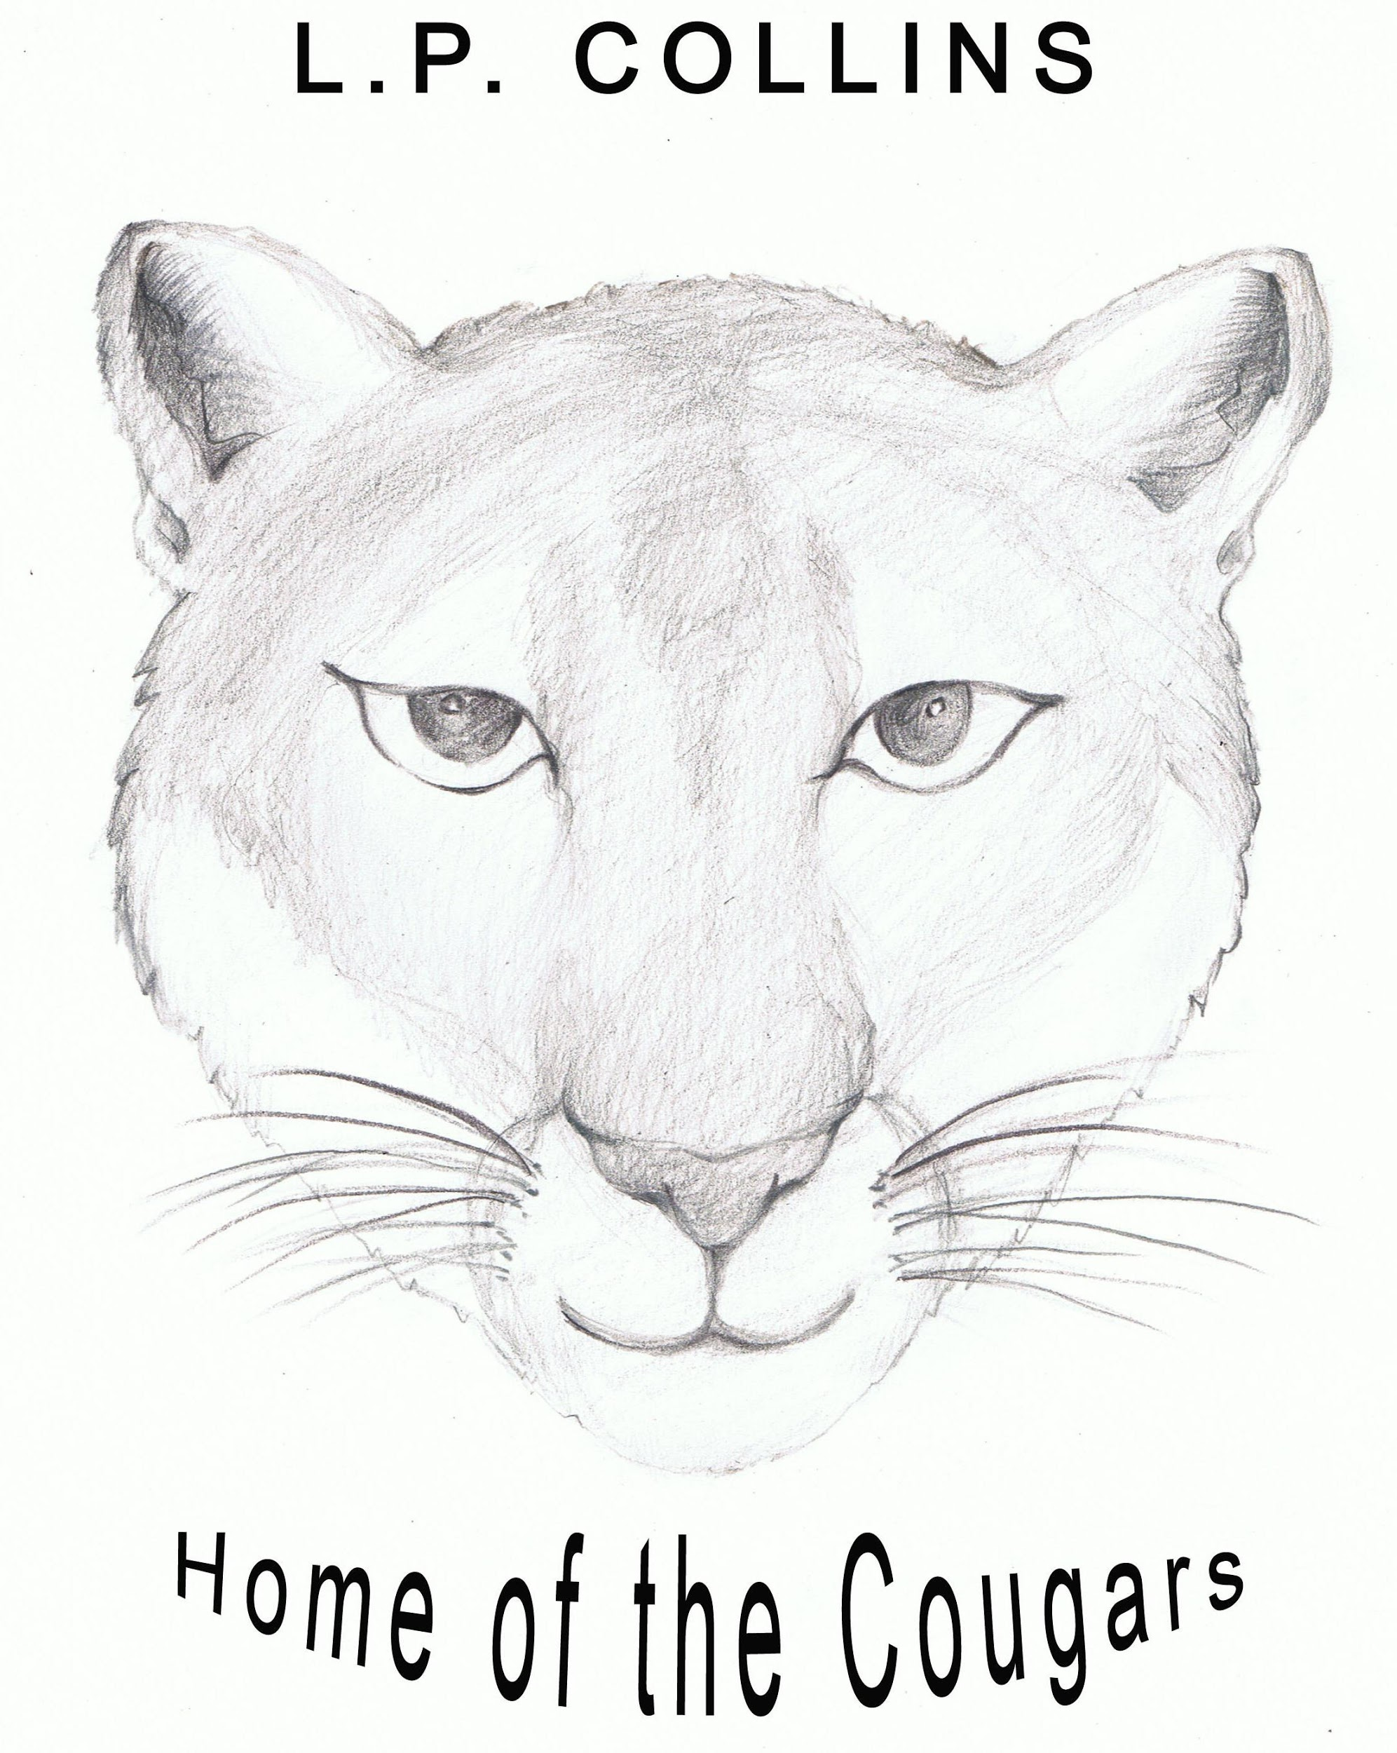

Collins Elementary School
Cupertino Union School District
Principal: Kerstin Johnson
10300 N. Blaney Avenue ~ Cupertino, CA 95014 ~ 408-252-6002
Fax: 408-253-3142

August 15, 2019

Dear Parents:

The third grade team has already started planning educational field trips and activities to enhance the curriculum. In order to cover expenses to many of these field trips and in-school programs that support and enrich our third grade curriculum, we are asking for a fee.

This fee makes possible outstanding learning experiences such as special assemblies, art projects, and a variety of field trips. It also allows us to purchase necessary materials in language arts, math, science, social studies, as well as arts and crafts. No child will be excluded from field trips or activities due to an inability to contribute; a fee is not required for participation. However, if the grade level does not receive sufficient fees by mid-September, classes will be unable to participate in one or more field trips.

The following are some things that are already planned or are in the planning stages:

*Asia Fantasia – storytelling presentation at Collins
*Ohlone Habitat” at Deer Hollow Farm - Social Studies
*Local Historical Museum - hands-on presentation to understand Santa Clara County history
*Creek Studies - at McClellan Park
*Fujitsu Planetarium at De Anza College
*Performing Arts- TBD
*“Let’s Look at Art”- classroom visit with art docent
*Pizza-My-Heart- supplements “The Economy of Our Region” in Social Studies

The total cost of these trips and activities is $75.00 per child. Checks should be made payable to Collins School and turned in by Friday, September 13, 2019. If desired, payments may be made on a trimester basis.

If your employer matches donations, the Collins Tax ID number is 77-0025265. If there is a space to specify the teacher name, please do so. Otherwise, you will need to notify the school secretary, Ms. Sharifi, so she knows which classroom it should go to.

Thank you in advance for your donation and support!

Sincerely,
Your Third Grade Teachers
Mrs. Min Mr. Nutter Mrs. Vadodkar
Ms. Momii Ms. Tapec Mrs. Wong

